**Restaurant e-management**

**System users**

1. Customer
2. Chef
3. Waiter (Server)
4. Restaurant Manager
5. Inventory Manager

**Functionalities of the users**

**Customer:**

Customer enters into a restaurant. The manager will look for empty tables with specified number of people. The table will be allocated to customer. Customer will have a device on table through which he can order the food items.

Customer can browse through the menu. He can chose category from appetizers, entrée and desserts. There is also sub-category for vegetarian non-vegetarian and vegan. Menu items are classified on these criteria (As in Fig 1 & Fig 2).

Fig 1. Main menu page where a user can browse through different categories. Default section is the Appetizers as highlighted above.

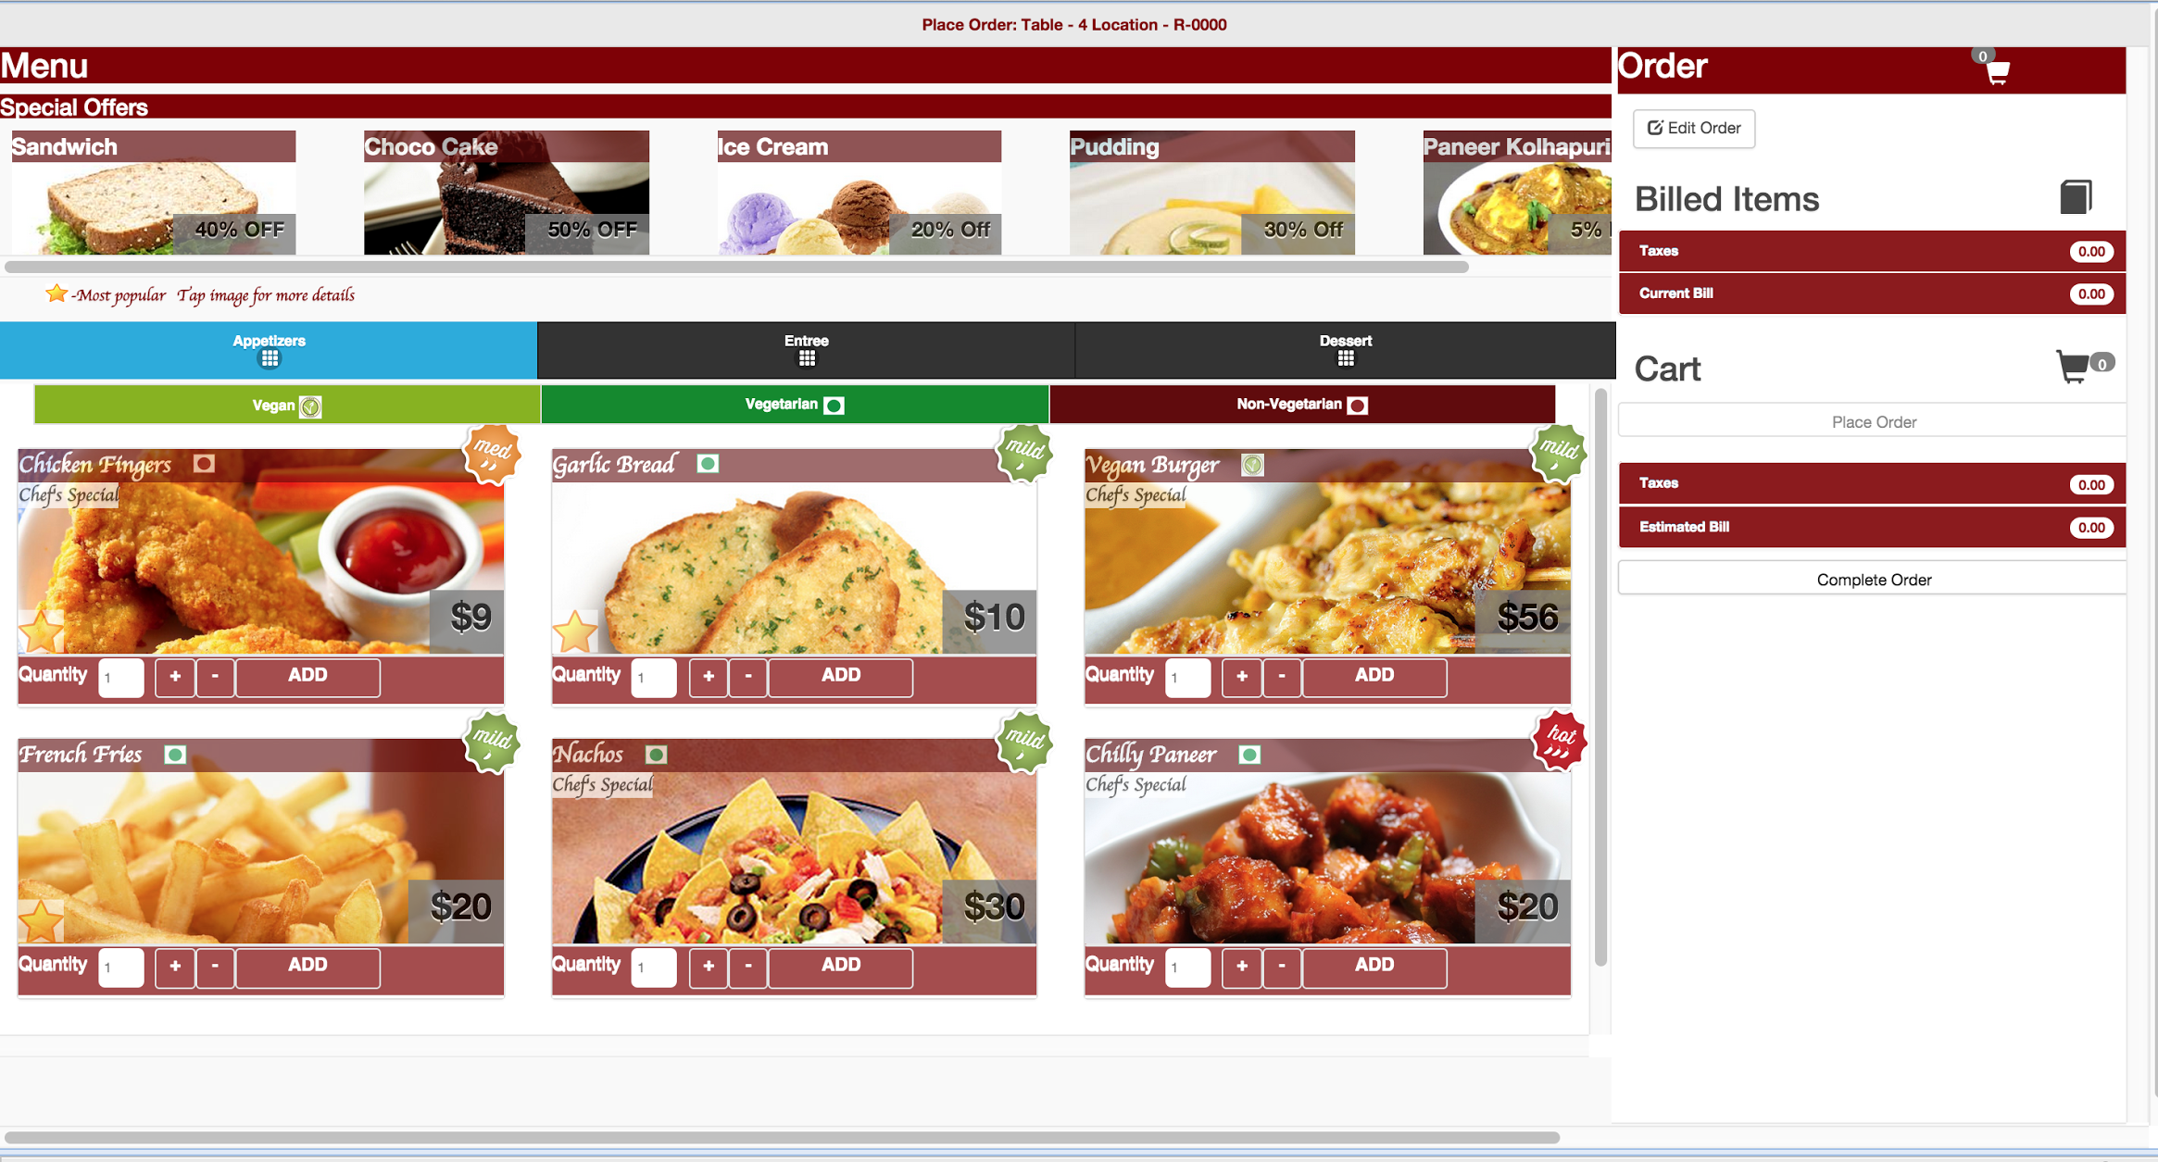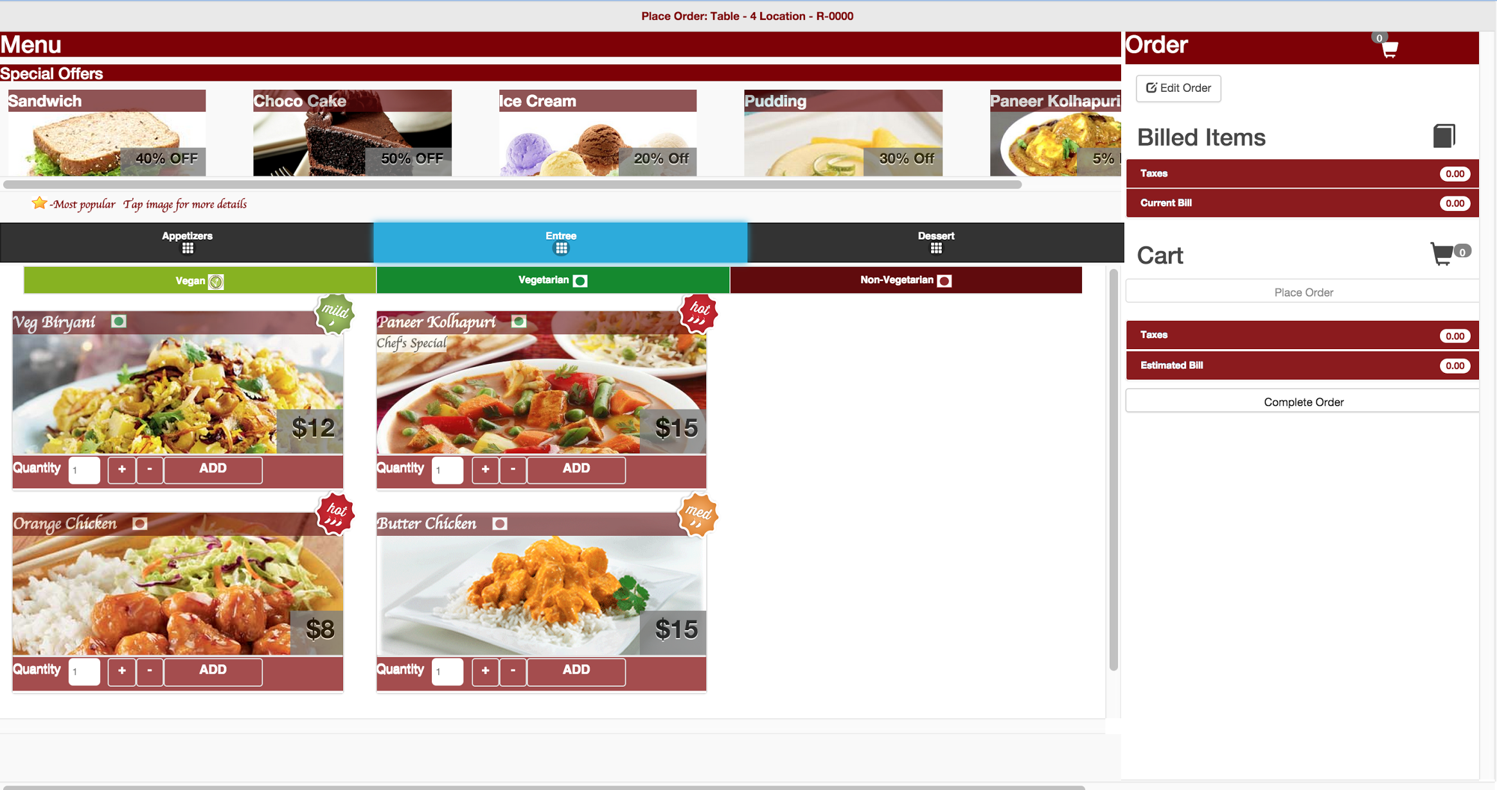

Fig 2. Customer can browse through another sections. Here the customer is on the Entrée section.

Customer can select the menu items and use and the ‘+’ & ‘-’ signs to increase/decrease quantity respectively. Add those to cart using the ‘Add’ option. The order of items will be the order in which they are added into cart on the right (as in Fig 3).

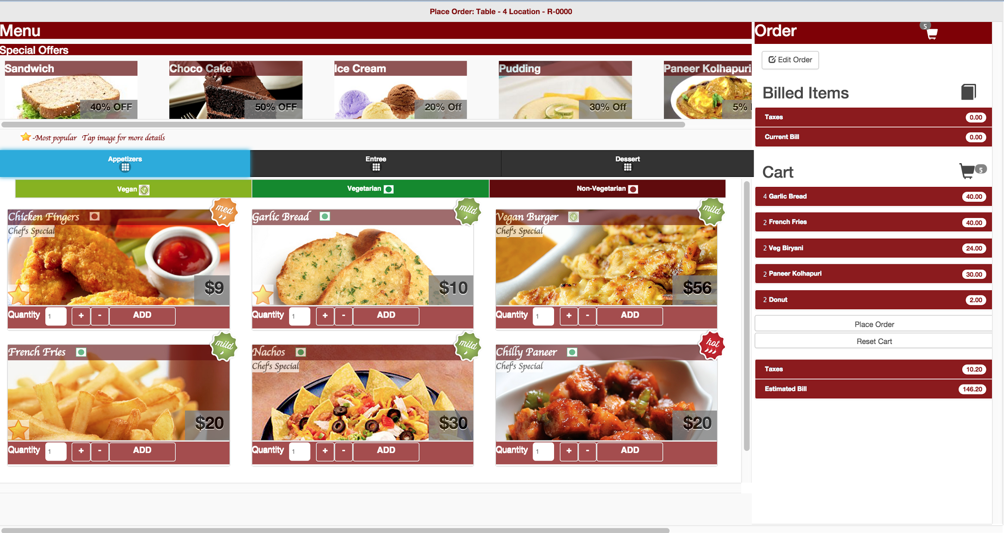

Fig 3. Clicking on Add button adds the items to the cart on the right side.

Customer can see the top selling items in the restaurant in each of the sections with a star mark on them.

Customer can view the bill and cart on right side of the screen. It will contain list of items selected by customer (as in Fig 4). Once the customer clicks on ‘Place Order’ the items get added to the ‘Billed Items’ section. Customer can add or remove items from cart using the ‘Edit Order’ button. Customer can also clear the entire cart by using the ‘Reset Cart’ option.

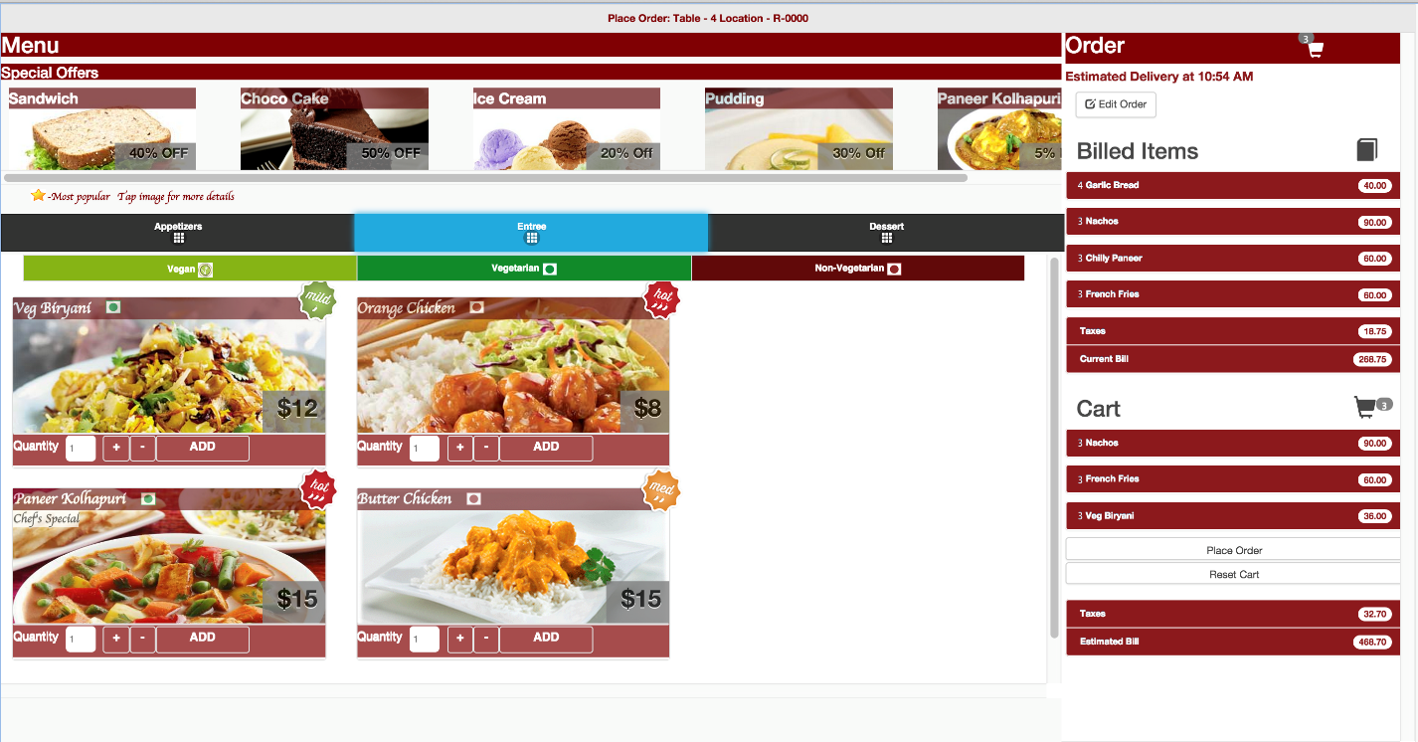

Fig 4. Items are added to the cart and the placed order items are under the Billed Items section.

Customer can view the total bill of the ordered items. When the customer clicks ‘Place Order’ button, the items from cart are moved to ‘Billed Items’ section. These confirmed items are now displayed on chef’s screen for processing (as in Fig 5).

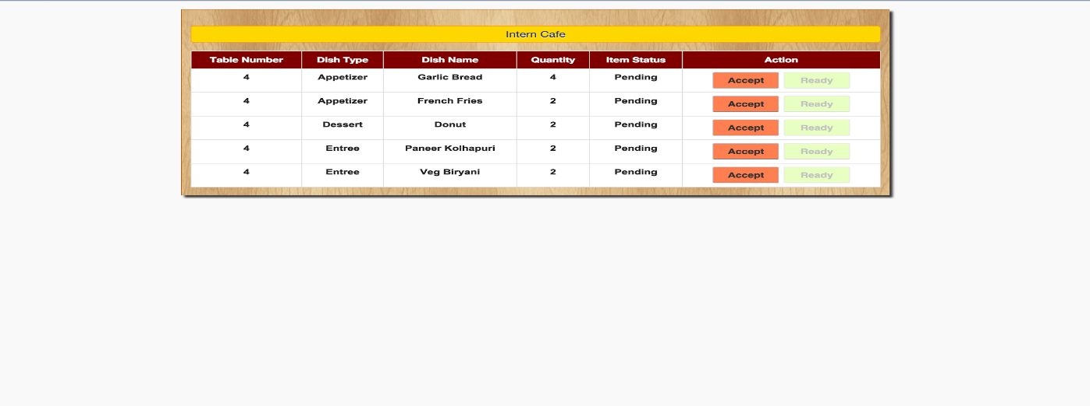

Fig 5. Chef’s screen as and when the order is placed by the customer.

Customer can edit these items before chef clicks the ‘Accept’ button. Once the chef accepts the items for preparation, customer cannot update those items. The tax will be added to the total bill and new amount to be paid will be displayed at the end. Edit Modal allows to increase/decrease quantity of the items or delete the items from the order.

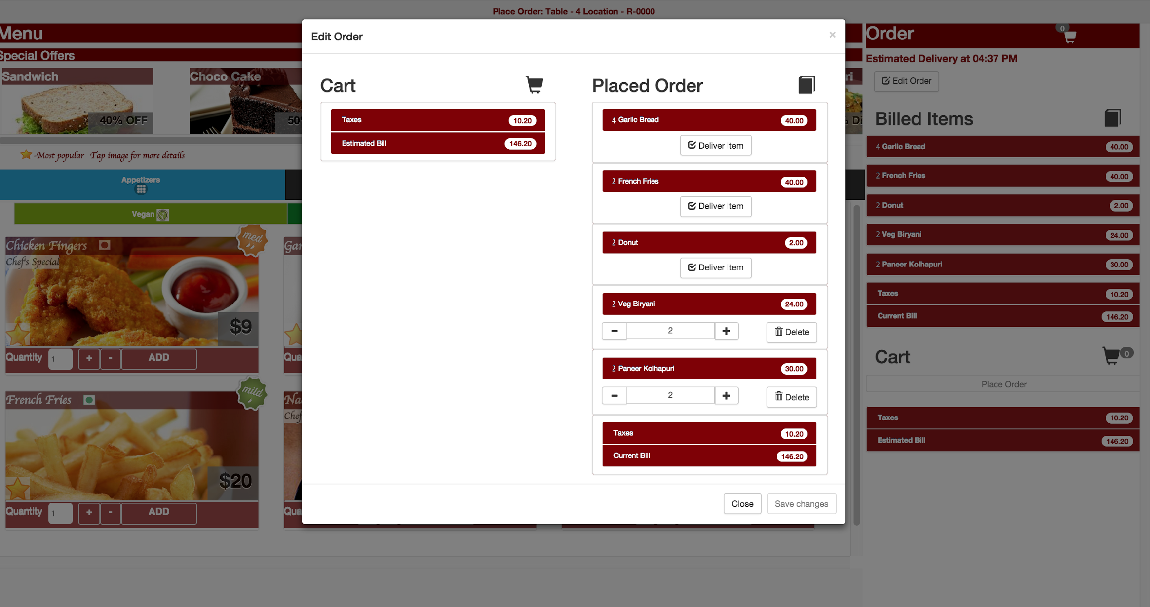

Fig 6. Edit modal opens up when user clicks on ‘Edit Items’ button.

Customer can see the delivery time for the first item to be served.

Before paying the bill, customer can provide the tip. Customer can also provide the feedback for the service and food (as in Fig 7, Fig 8).

Fig 7. Bill Page shows the amount to be paid, add tip and allows user to pay the amount.

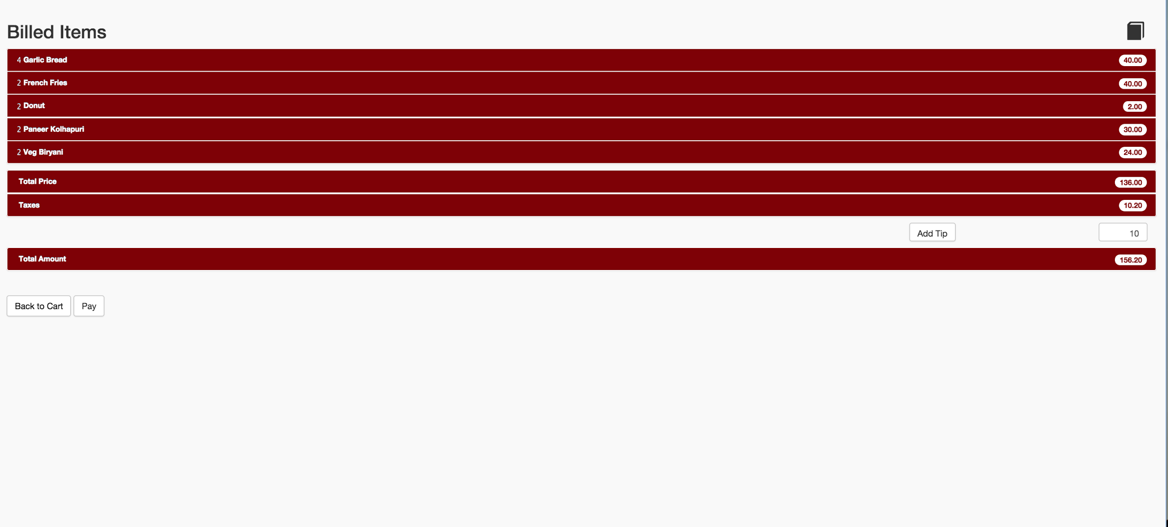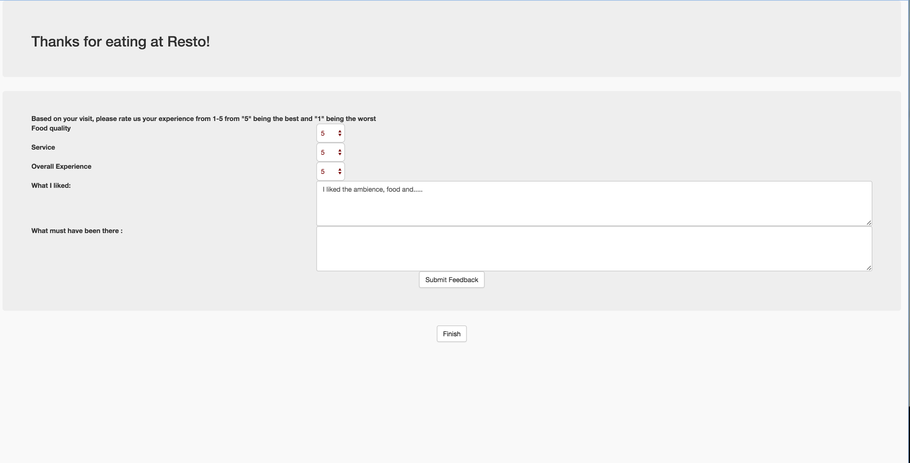

Fig 8. Feedback form available to customer.

**Chef:**

When the Chef logs in, he first selects the number of chefs in the kitchen at present (as in Fig 9). This will be used for delivery estimation of an item.

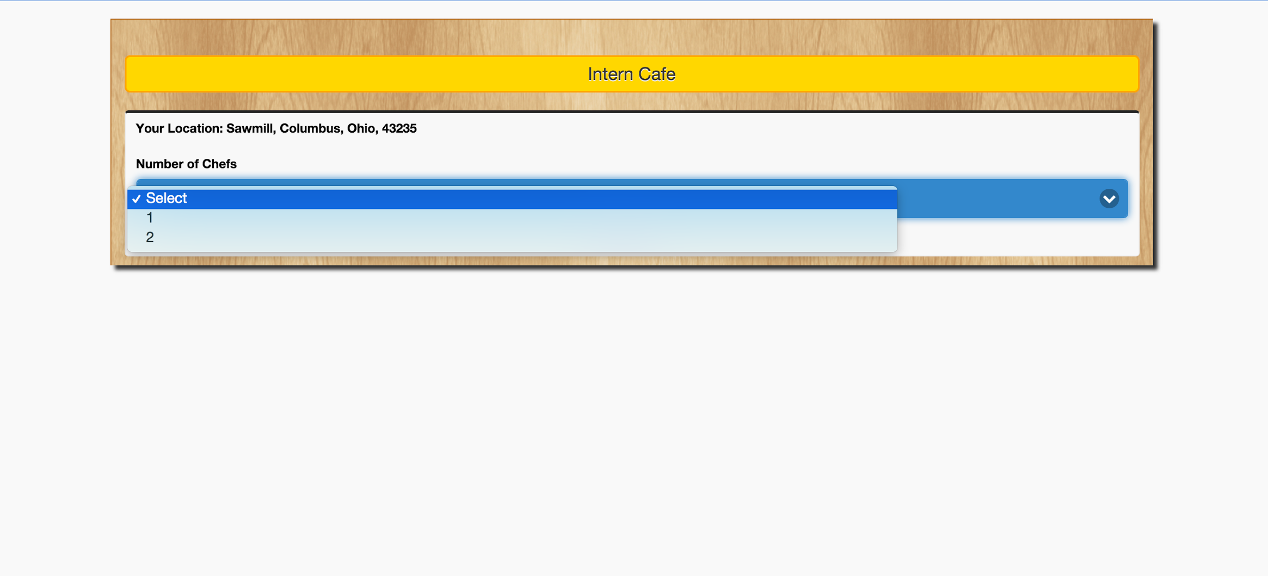

Fig 9. Landing page of the chef

When the customer clicks ‘Place Order’ button, chef’s screen (as in Fig 10) will get the list of items to be prepared. The order of item will be the order in which the order is placed. Chef’s screen displays the queue of items that were ordered. The chef accepts the order by clicking the ‘Accept’ button. From this moment, the customer cannot edit the accepted items.

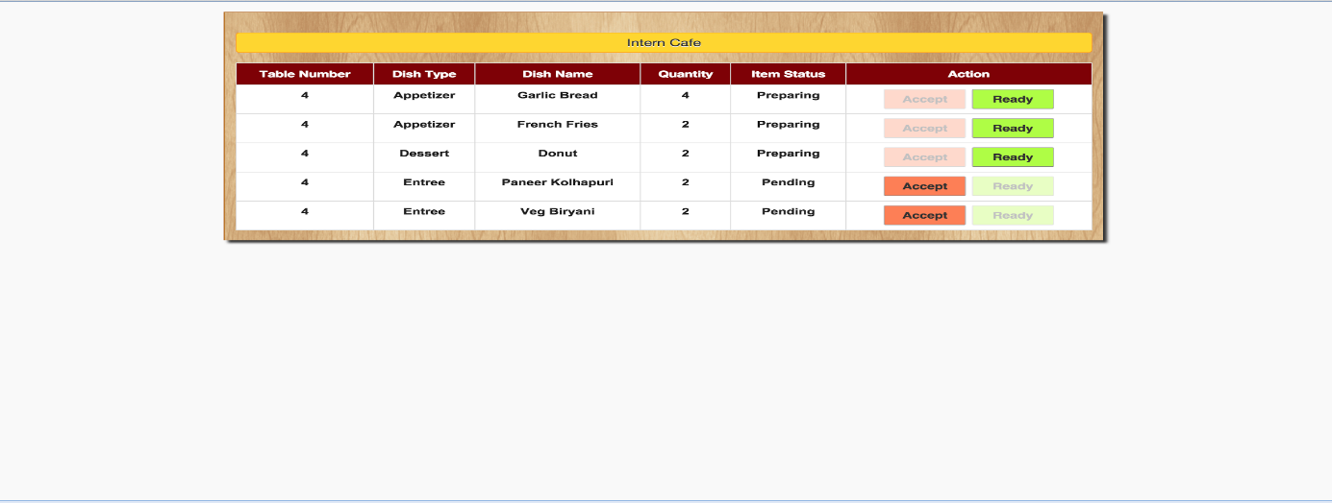

Fig 10. Chef’s screen with some orders that have been accepted and are being prepared. Some orders waiting to be accepted.

When the item is cooked, he will update the item to Ready state. At this time, this item will be added to waiter’s screen. Chef can view the list of total items ordered in that restaurant.

**Waiter:**

This screen (as in Fig 11) will display the list of items prepared by chef and which are ready for pickup. Once the waiter picks up the item and servers at the table, he/she will change the status of item to Delivered using the ‘Delivered’ button in the Edit modal. Then the items will have the delivered e-stamp on them (as in Fig 12).

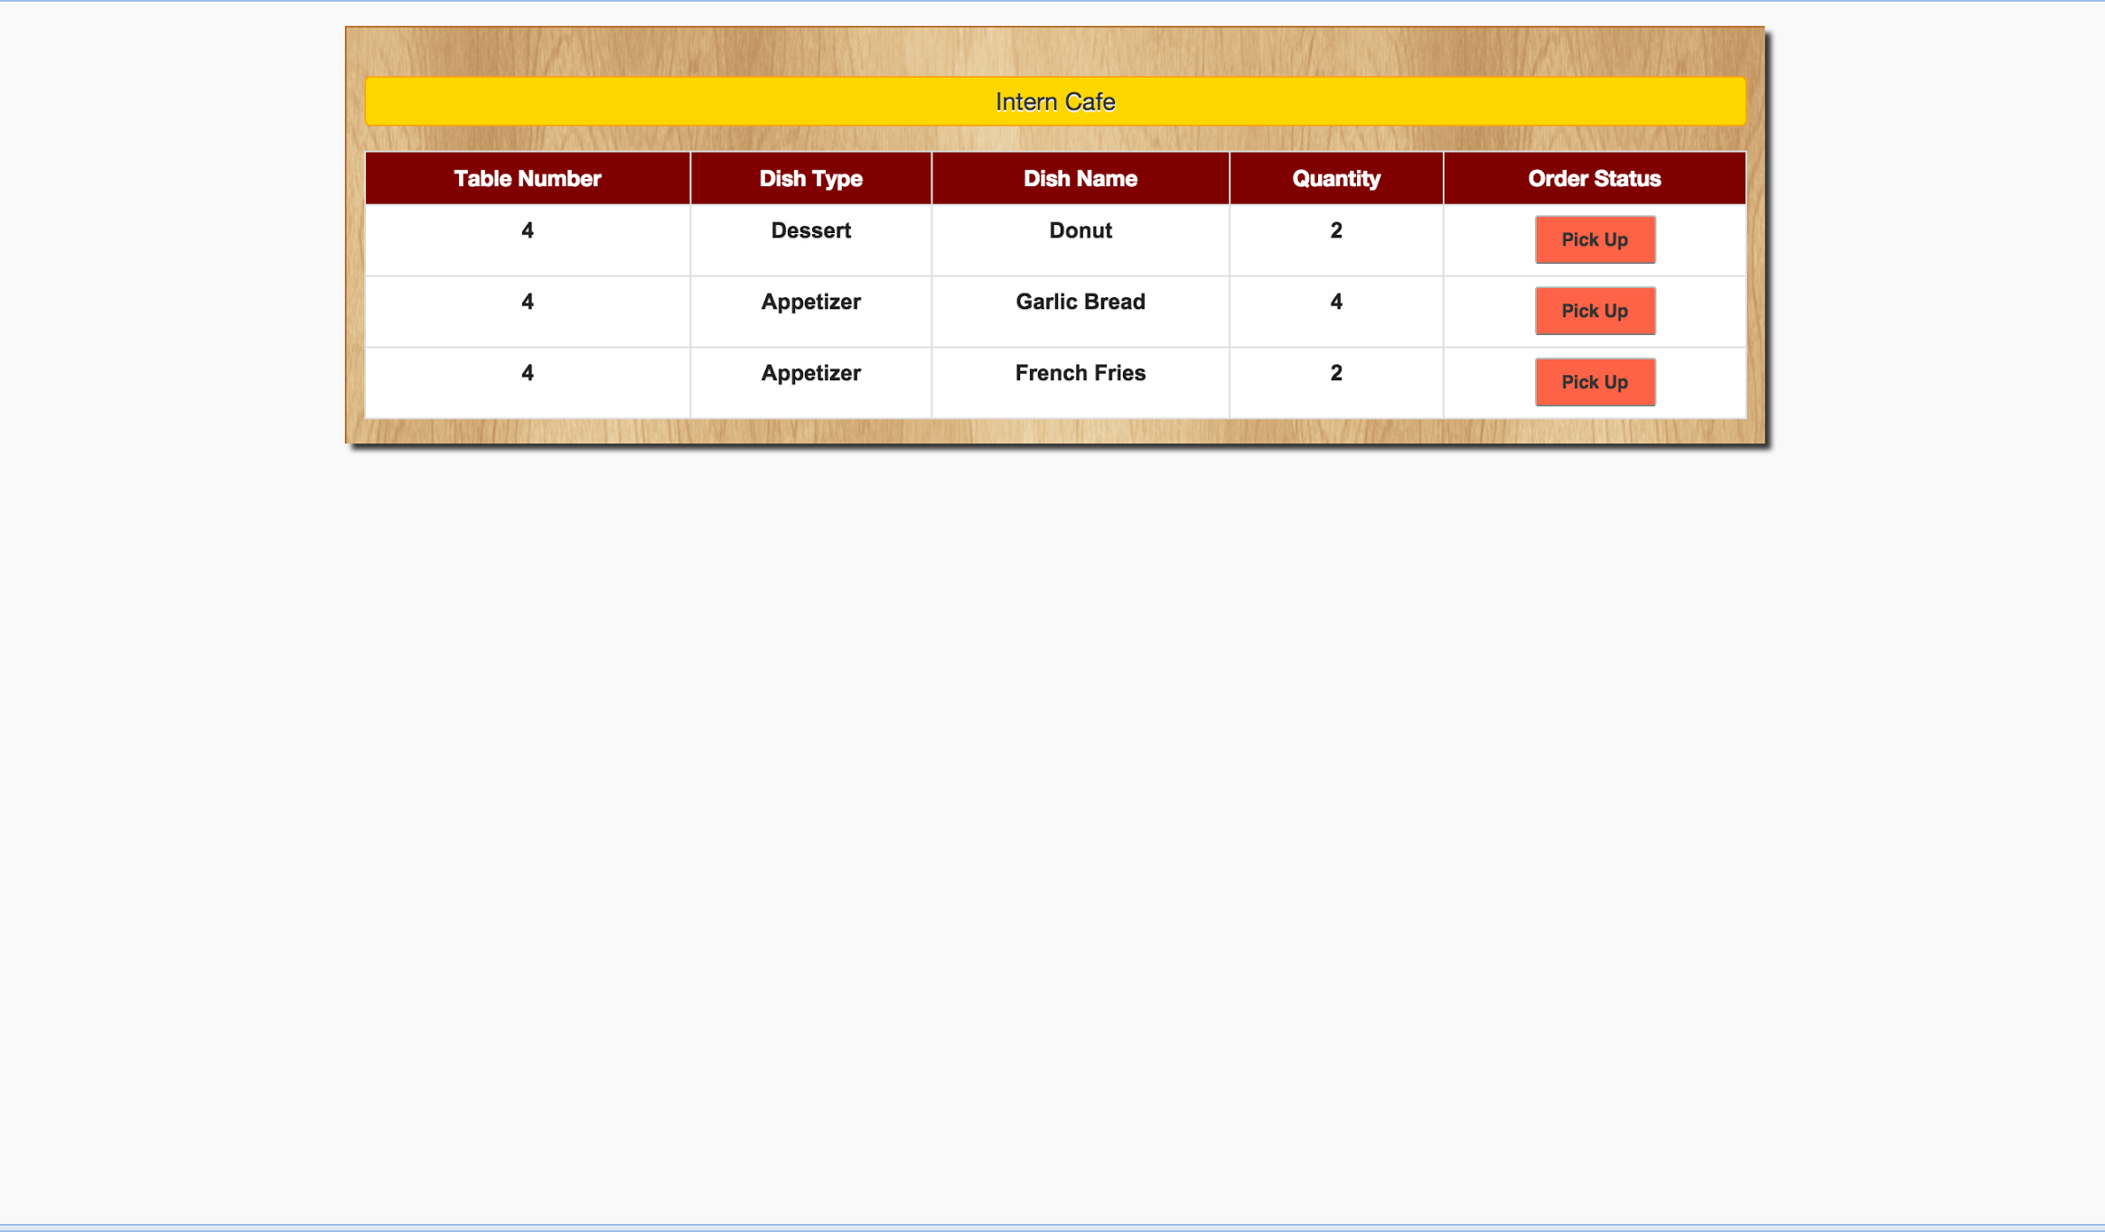

Fig 11. Waiter’s screen with the list of ready orders.

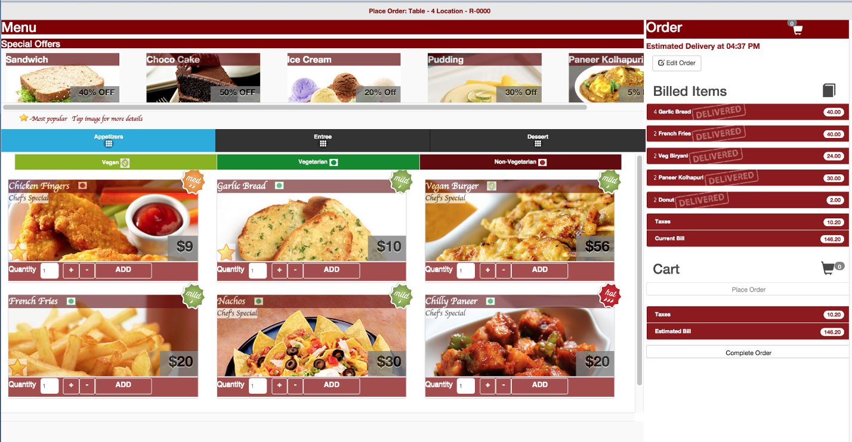

Fig 12. Items have the Delivered e-stamp on the items that have been delivered.

Once the customer finishes ordering, waiter can mark the order as complete.

At the end, waiter can proceed with payment from the customer and will mark the order as paid.

**Front Desk Manager:**

She/he can update the status of the tables in the restaurant. Also she/he can assign appropriate table to the customers depending on the availability and number of guests (as in Fig 13).

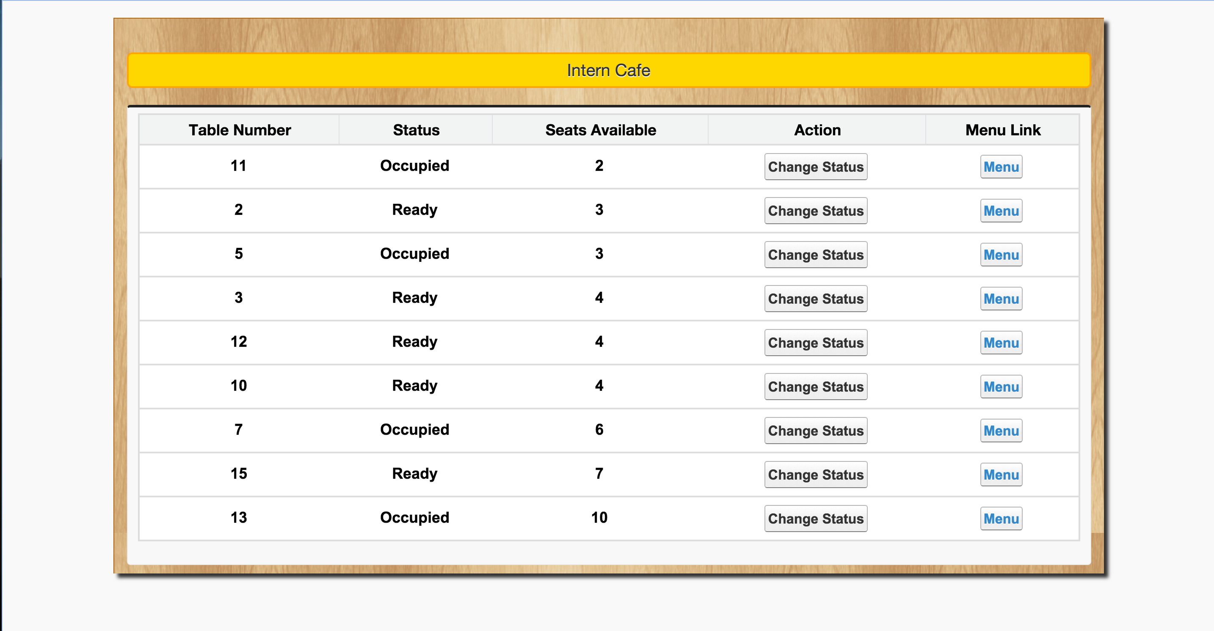

Fig 13. The table status lists for the restaurant

**Restaurant Manager:**

She/he can add, delete or modify the information about the food items. Also, she/he can modify the information about the restaurant.

Restaurant Manager can view the weekly, monthly and annual sales for his/her outlet using the filters on the report section. This can be done using the Reports section where we have several reports to show the statistics pictorially (as in Fig 14).

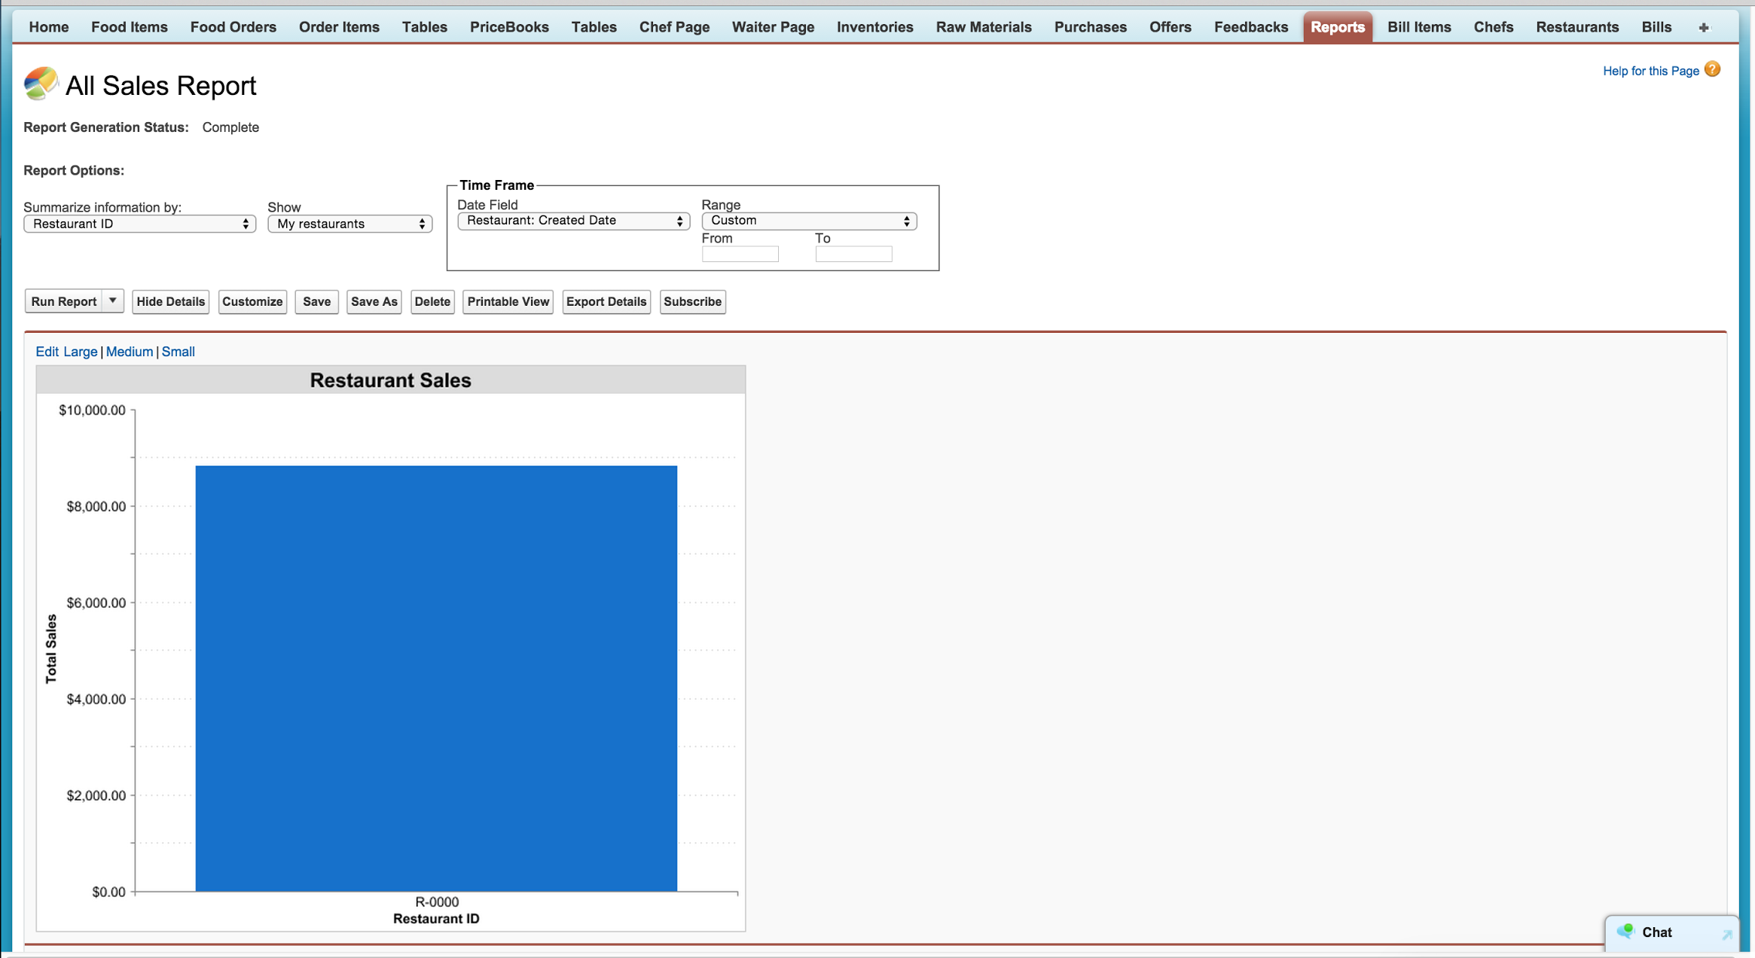

Fig 14. Sales report visible to the people at managerial level.

She/he can view the current inventory position of the restaurant. Also restaurant manager can update the inventory items. She/he can view the forecast of items in the inventory that are to be replenished.

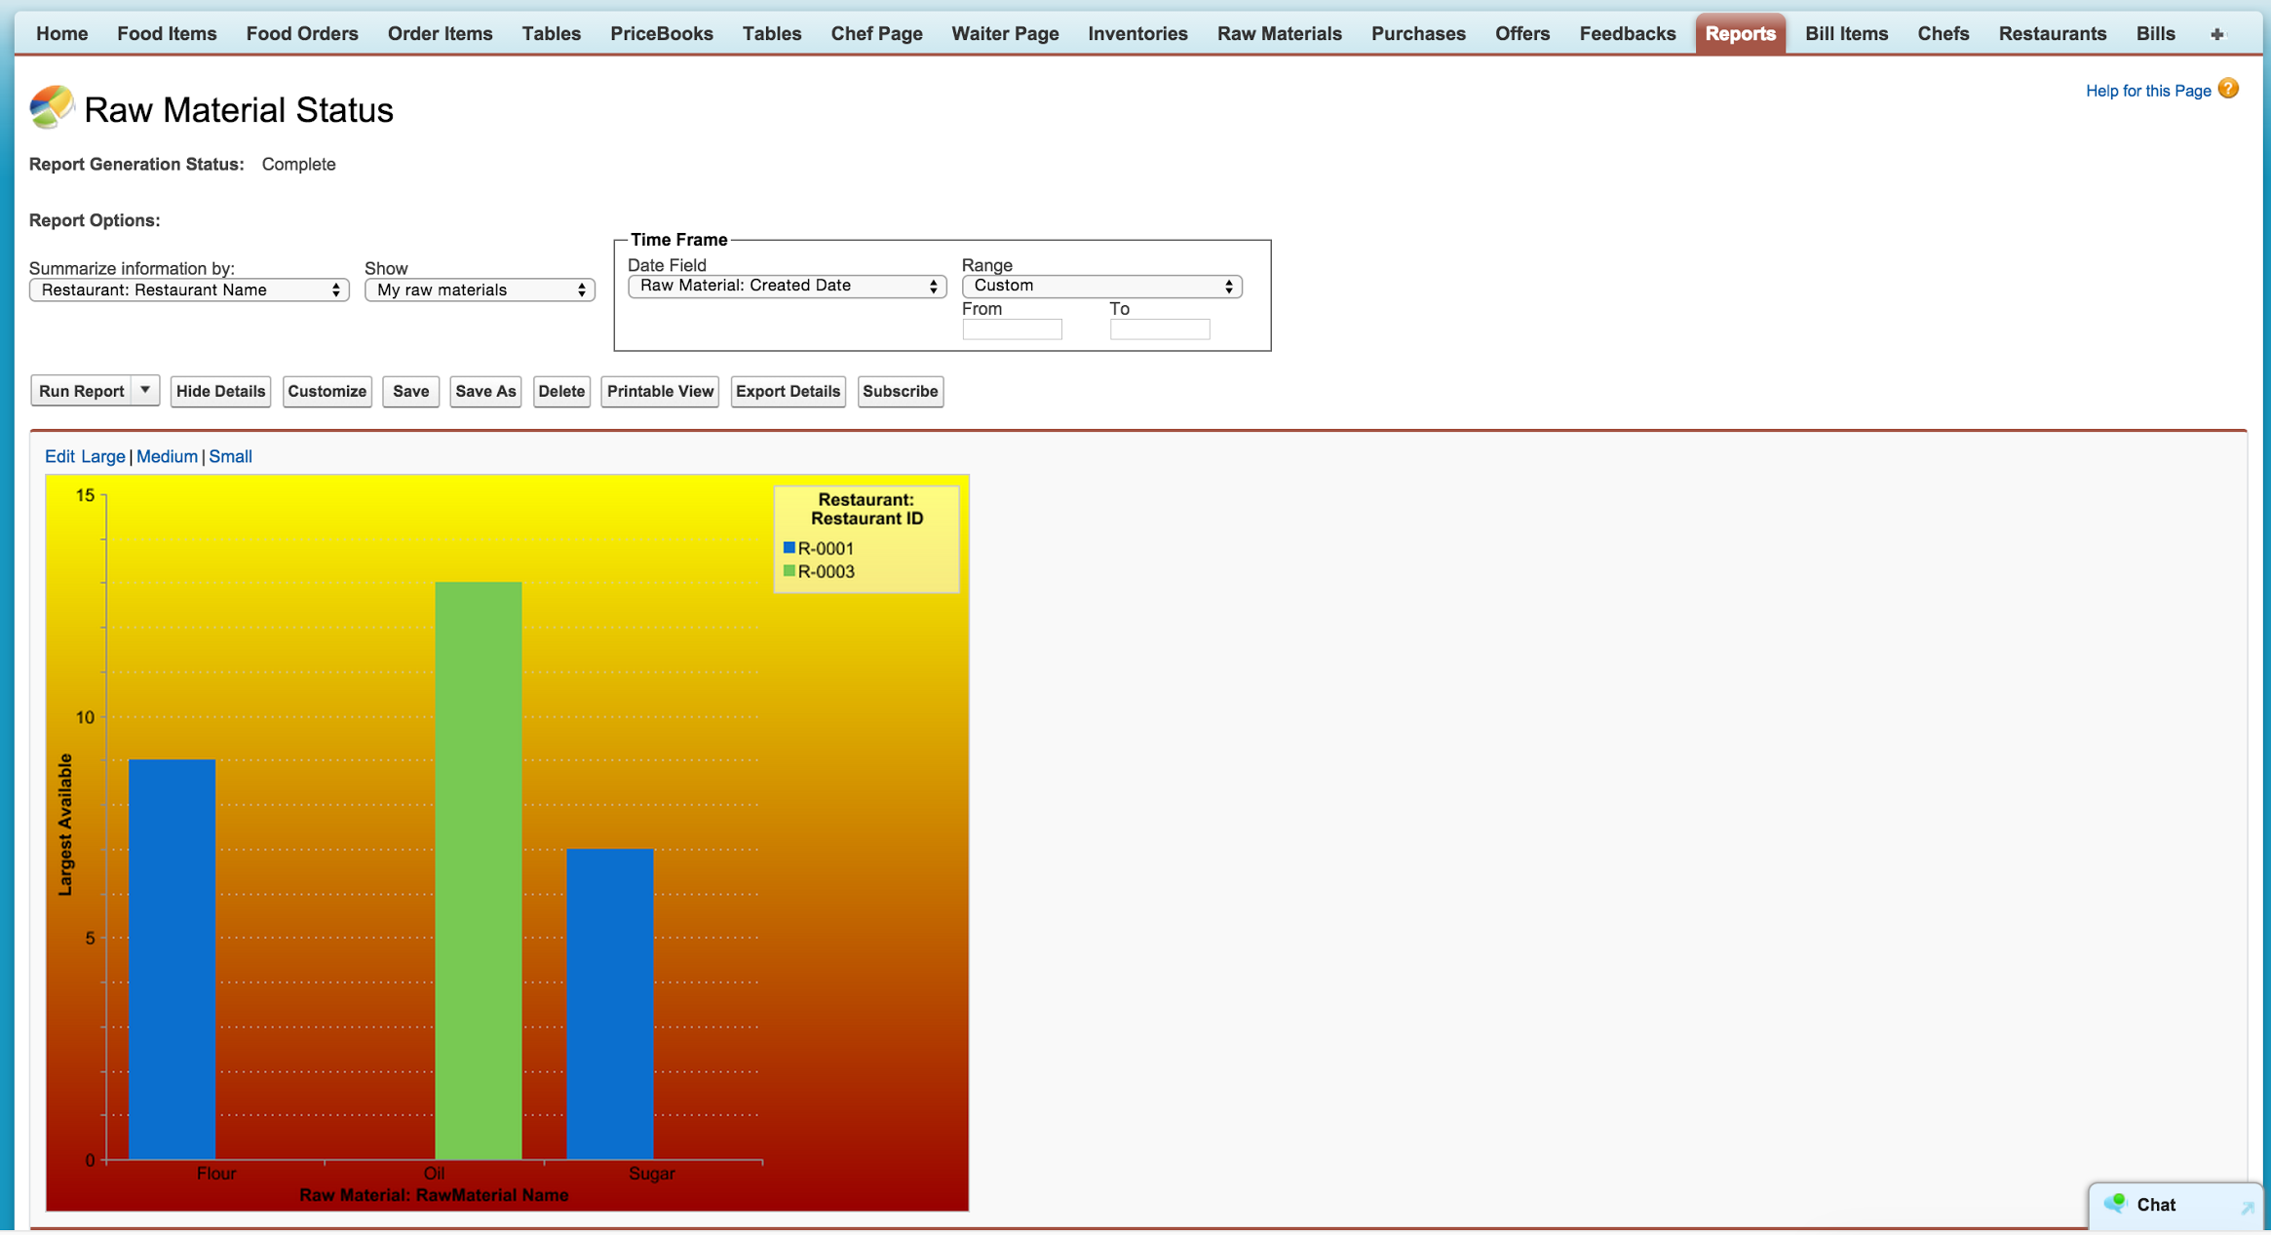

Fig 15. Inventory chart for quick update on the items in repository.

**Higher Manager:**

She/he can view restaurant wise weekly, monthly, quarterly and annual sales of the restaurant. Also she/he can view the most popular items, average bill and least popular items for further actions in menu management across the chain as well as per restaurant.

**Screens**

**Table Screen**

This is the first screen. The restaurant manager gets the list of table details with seats available and status in his restaurant. The guests will be allocated appropriate table. When the table is selected, the status is changed to Occupied.

Controller Name: TableController

Page Name: TestTables

**Menu Screen**

This page displays the menu items. On the upper side, special offers are displayed. Menus are divided into 3 sections namely appetizers, entrée and dessert. In each section, user can select vegetarian, non-vegetarian and vegan items. By clicking on the item, customer can view the food details. By pressing Add button, the item will be added in the cart.

The cart is displayed on right side. The items in the cart can be modified before the place order button is clicked. Customer can see the total amount to be paid along with the taxes. When the item is delivered, waiter will mark item as delivered.

Controller Name: MenuItemListController

Page Name: Menu

**Bill Screen**

This page gets enabled when all the items in the order are delivered. This page will display the name, quantity and amount for each item. The total will be displayed below it. Bill Page also has option to provide tip. This will change the total amount. By clicking on done button, the order is completed and order will be closed.

If customer wants to order more items, then Back to cart button needs to be clicked. This will take the customer to menu page.

At the end of the page, customer can give feedback;

Controller Name: Bill

Page Name: Bill

**Chef Screen**

This page displays the list of ordered item by customers. Chef will click Accept button when he starts cooking the order item. After this moment, customer cannot modify the item count that chef has started preparing. When the item is ready, chef will click on Ready button. This will notify the waiter screen that item is prepared. Now waiter will serve the particular item.

Controller Name: ChefListController

Page Name: Chef_Pending_Orders

**Waiter Screen**

This page displays the list of food items which are ready to deliver. Waiter will pick the items and deliver to the table number specified with the item. He will click on Pickup button when he takes the item.

Controller Name: WaiterListController

Page Name: WaiterPendingOrders